|  |  |  |
| --- | --- | --- |
| **LAB 321Assignment** | **Type:** | **LongAssignment** |
| **Code:** | **J3.L.P0037** |
| **LOC:** | **150** |
| **Slot(s):** | **5** |

**Title:** Website contact page

### A contact page is a standard web page on a website used to allow the visitor to contact the website owner or people who are responsible for the maintenance of the site. The page often contains one or more of the following items:

### • a mailto link to an e-mail address.

### • a description of personality like a (organization) name, address, zip code, residential area, with sometimes a map indicating a certain physical location and a description or visualization of how to get there;

### • a set of visual icons or textual links to social networking services;

### • a contact form with entries where the visitor can fill in their name, subject and message and send or reset it.

**Program Specifications**

In this assignment, you are requested to develop a contact page with a contact form.The visitor could enter their information and send it. All contacts of visitors would be viewed by the website owner in order to handle them.

**Features:**

This website contains 2 main functions

* Function 1: Contact front end (PIC 1)
  + Main actor: anomalous visitors
  + Normal flow: The actor access to website, click on menu “contact us”, the form with the following entries:
    - First Name
    - Last Name
    - Email
    - Comment
  + Other advanced features:
    - Depend on individual purpose, some information of visitor such as phone, location… should be gathered via your contact form.
    - Validate should be considered to make sure the actor enter a valid form of email, phone…
    - Some information should be marked as required information. The actor could not send the form without filling them.
    - A cap char service or equivalent mechanism should be used in order to make sure the information really come from a human, not from a auto generated robot.
    - Form should be responsive.
* Function 2 : Contact us Back-endpage (PIC 2)
  + Actor: site owner, site administrator
  + Normal flow: actor view a separated page from front-end contact form. This page allow the actor retrieves every contact inputtedfrom front-end, organize as a list of contact records and sorted by created date.
  + Backend contact form allowsactor to click and view one record, and marked it as handled.
  + Allows actor edit the content of every contact form.

***Expectation of User interface:***

***(This prototype is creation by .Net IDE, so you do not need to design the user interface absolute accuracy , but all function must work properly)***

Pic 01 : Contact us form

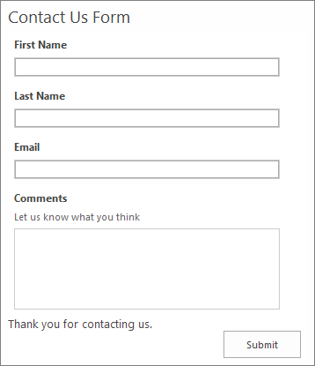

PIC 2 :Back-end

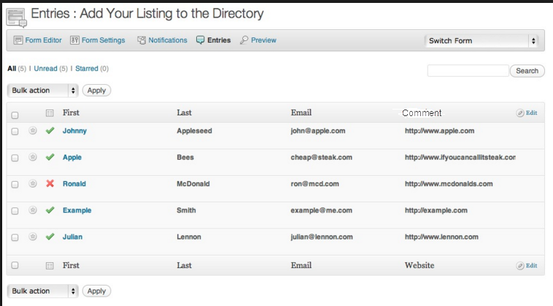

**Guidelines**

* Step 1 : Create web layout
* Step 2 : Create prototype
* Step 3 : Design database base on created prototype
* Step 4 : Code & Test